Electronic Structure

The shell number is also called the principle quantum number
Sub shells are made up of a series of orbitals, each orbital holds 2 electrons
Orbitals are regions where the probability of finding an electron is the greatest.
Electrons are represented with arrows, showing their spin. Electrons in orbitals must have opposite spins, if there are 2 electrons in the orbital.
Sub shells fill singly first, then doubly, so:
Is incorrect
↑↓ | ↑↓
Is correct as the electrons are equally distributed
↑↓ | ↑ | ↑

The shells try to minimise unpaired electrons, and spin inside the orbitals must be opposite.

Sub Shell | Orbitals | Electrons | Total Electrons
1 | 1 | 2 | 2
2 | 3 | 6 | 8
3 | 5 | 10 | 18
4 | 7 | 14 | 32
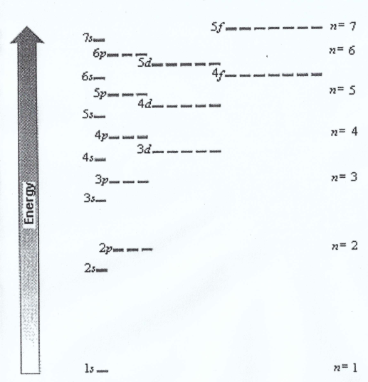
Sub shell 3d has a higher energy than 4s, so 4s fills before 3d.
But as soon as 4s is filled, 4s has a higher energy than 3d.
This means that electrons are lost from 4s before 3d.
Electrons are always lost from the highest energy level.

